Technical Report for the Global Slavery Index Performance Analysis for the Year 2023
Introduction
Modern slavery is hidden in plain sight and is deeply intertwined with life in every corner of the world. Each day, people are tricked, coerced, or forced into exploitative situations that they cannot refuse or leave. Each day, we buy the products or use the services they have been forced to make or offer without realising the hidden human cost. An estimated 50 million people were living in modern slavery on any given day in 2021, an increase of 10 million people since 2016.

What is the Global Slavery Index?
Walk Free’s flagship report, the Global Slavery Index (GSI) provides national estimates of modern slavery for 160 countries. The estimates draw on thousands of interviews with survivors collected through nationally representative household surveys across 75 countries and the assessment of national-level vulnerability. With the exception of contributions from external authors, the Global Slavery Index is produced by Walk Free.

Objective of the Project
The objective of this project is to analyze global patterns of modern slavery and human trafficking using reliable secondary data, with the goal of identifying key risk factors, regional disparities, and policy response gaps. By exploring indicators such as slavery prevalence, vulnerability scores, and government response efforts, the aim of this project are as follows:
- Highlight the regions and countries most affected by modern slavery.
- Identify the major contributors to vulnerability, such as governance issues, inequality, and conflict.
- Evaluate the effectiveness of government actions in supporting survivors and preventing exploitation.
- Establish correlations between risk factors and slavery rates, offering insight into root causes.
- Recommend data-driven strategies for prevention, intervention, and advocacy.
The project seeks to turn complex global slavery data into meaningful insights that can support human rights advocacy, policy design, and more effective anti-trafficking interventions.

Data Collection Process
For this project on Human Trafficking Analysis, we utilized secondary data sourced from the Global Slavery Index 2023, published by Walk Free. This dataset is recognized globally for its rigorous methodology and comprehensive coverage of modern slavery, including human trafficking. The data captures critical indicators related to the prevalence, vulnerability, and government response to modern slavery across 160+ countries.

Why did we choose this dataset?
- Credibility and Scope
Walk Free’s Global Slavery Index is developed using a combination of nationally representative surveys, expert consultations, and validated statistical models. It is widely cited by international organizations such as the UN, ILO, and NGOs working in human rights and anti-trafficking.

- Relevance to Our Task
The dataset directly supports the subtopics assigned to our team, especially:
- Policy effectiveness and gaps: Through government response indicators (i.e. justice systems, survivor support, regional coordination).
- Victim profiles and vulnerability: Using variables like governance issues, inequality, disenfranchised groups, and effects of conflict, which help explain the social conditions that allow trafficking to thrive.
- Regional trends: The dataset includes country and regional breakdowns that allow us to explore patterns and risk across different geographies.

- Quantitative Strength
The dataset allows us to work with numerical indicators such as estimated prevalence per 1,000, vulnerability scores, and government response scores which can be analyzed, compared, and visualized effectively with tools including Excel and PowerBI. This helps us generate evidence-based insights that can inform advocacy, policy discussions, and awareness.

How the Data Was Collected
The Global Slavery Index aggregates data from:
- Nationally representative surveys in over 75 countries conducted in partnership with Gallup World Poll.
- Administrative data from international agencies, such as UNODC and IOM.
- Expert input from regional specialists and frontline NGOs.
- Model-based estimates for countries where survey data is not available, using statistical techniques to ensure consistency.

The Global Slavery Index 2023 provides a reliable and comprehensive foundation for analyzing the complex issue of human trafficking. Its combination of prevalence data, vulnerability indicators, and government response metrics aligns directly with the project’s goals. Particularly in assessing regional risks, profiling vulnerable populations, and evaluating policy effectiveness. By effectively using this well-documented dataset, our team can generate meaningful insights and analysis that not only support awareness but also inform evidence-based recommendations for prevention and intervention strategies worldwide.

Methodology
In this project we used a data-driven descriptive and comparative analysis approach to explore global patterns of modern slavery and human trafficking. The methodology is structured into the following key steps:
- Data Source and Collection
The data used for this project was sourced from the Global Slavery Index 2023, published by Walk Free, a globally recognized organization focused on human rights and modern slavery research. The index combines data from multiple international sources including the International Labour Organization (ILO), national household surveys, and various legal and policy assessments. It covers over 160 countries and provides detailed indicators on slavery prevalence, vulnerability factors, and government response metrics.

- Data Preparation and Cleaning
Once downloaded, the dataset was cleaned and prepared using Microsoft Excel. Non-essential text rows (such as headers and footnotes) were removed, column headers were standardized, and all numeric values (especially percentages and index scores) were formatted properly. Missing data entries were reviewed and handled appropriately to ensure consistency. These steps ensured the dataset was structured correctly for analysis using pivot tables and charts.

- Analytical Framework
The analysis followed a descriptive and comparative framework focused on three main areas:
- Slavery prevalence per 1,000 population.
- Vulnerability scores, broken down into governance issues, inequality, lack of basic needs, disenfranchisement, and conflict.
- Government response scores, including survivor support, justice system effectiveness, international coordination, risk factor mitigation, and bans on forced labor.
These indicators were analyzed across countries and grouped by regions to observe trends and disparities.

- Data Analysis in Excel
The main analysis was conducted in Excel using PivotTables to group data, calculate averages, rank countries, and compare variables. Calculated fields were used to measure gaps (e.g., between vulnerability and government response scores). Conditional formatting helped highlight extremes in scores to visually emphasize key data points and trends. The flexibility of Excel enabled both macro (regional) and micro (country-level) insights.

- Data Visualization Techniques
A variety of data visualization techniques were applied throughout the analysis to enhance clarity and highlight key insights. These included bar charts, column charts, pie charts, scatter plots, combo charts, and summary cards. These visuals were created in Microsoft Excel and integrated into the dashboard to present the data in a clear, accessible, and engaging format for our stakeholders.

- Insight Development and Hypothesis Generation
From the analysis, meaningful insights were drawn and hypotheses developed. For instance, countries with high conflict and poor governance often showed higher slavery prevalence. On the other hand, countries with strong justice systems and support structures for survivors tended to report lower rates. These patterns helped frame discussions on what factors drive modern slavery and which areas require urgent intervention.

Data Cleaning Procedures
The dataset underwent a thorough cleaning process to ensure it was accurate, consistent, and fully optimized for analysis in Excel.
- Unnecessary items such as a chart on the far right of the original sheet and a logo in the top-left corner were removed, as they were unrelated to the data.
- Additionally, grouping labels like “Prevalence,” “Vulnerability,” and “Government Response” above the column headers were deleted to eliminate redundancy and ensure compatibility with Excel’s filtering and sorting functions.
- All relevant percentage values were already correctly formatted, and no conversion was required.
- A check for duplicate entries revealed no repeated country records or rows. The dataset was also reviewed for blank rows and cells, and no empty or incomplete sections were found across required fields.
- Text entries, particularly column headers, were inspected for consistency in spelling and formatting, with no discrepancies identified.
- To further enhance usability, the dataset was converted into a structured Excel Table format. This facilitated improved filtering, sorting, and dashboard creation.
- Column headers were shortened to more concise, meaningful terms to improve clarity, such as renaming “Estimated prevalence of modern slavery per 1,000 population” to “Slavery per 1,000.”
- A separate “Header Key” sheet was also created to provide simple explanations for each column header, making the dataset accessible to both technical and non-technical users.
- Additional formatting included centering all numeric columns for readability, correcting any negative values that had been mistakenly stored as text (e.g., spaced-out minus signs), and applying Freeze Panes to keep header rows visible while scrolling through the data.

As a result, the dataset is now clean, structured, and fully analysis-ready—compatible with Excel formulas, PivotTables, and visualizations. It supports clear communication of insights in dashboards and reports, while remaining user-friendly for diverse audiences.

Pre-Analysis Phase
Story of the Data
This dataset presents a global overview of human trafficking vulnerabilities, government responses, and socio-political conditions contributing to modern slavery. It includes indicators such as population size, regional classification, estimated slavery rates, governance challenges, basic human needs gaps, and justice system effectiveness. The dataset aims to expose the root causes of trafficking, assess national vulnerabilities, and evaluate government efforts toward eradication. It serves as a foundational resource for policy formulation, NGO interventions, and global monitoring of anti-trafficking progress

Industry Type of Data
- Industry: Human Rights / Social Justice / Public Policy
- Government Anti-Trafficking Agencies
- International NGOs (e.g., Walk Free, IOM, UNODC)
- Human Rights Organizations
- Policy Research & Academic Institutions
- Journalists and Advocacy Groups

Stakeholders of the Project
Vephla University

What Success Means to the Industry
- Reduced Vulnerability Scores across countries
- Lower Slavery Estimates per 1,000 people
- Increased Survivor Support & Justice Effectiveness
- Strong Governance & Policy Implementation
- Holistic Reduction in Risk Factors (e.g., Conflict, Disenfranchisement, Inequality)
- Improved Global Cooperation & Compliance with Forced Labour Bans

Data Splitting
The dataset was split into two categories. The Independent Category and the Dependent Category.
Category One - The Independent Category
- Country
- Region
Category Two - The Dependent Category
- Slavery per 1,000 Population
- Slavery Estimate
- Total Vulnerability Score (%)
- Government Response Score (%)
- Government Coordination (%)
- Risk Addressed (%)
- Forced Labour Ban (%)
- Governance Issues
- Basic Needs Gap
- Inequality
- Disenfranchised Groups
- Conflict Impact
- Survivor Support (%)
- Justice Effectiveness (%)
- Population

Potential Analysis Questions
- Which country has the highest estimated number of people in modern slavery?
- What region has the highest average slavery rate per 1,000 population?
- Which countries have the highest slavery rate per 1000 population?
- What factors contribute most to vulnerability?
- Which region has the highest overall vulnerability score average?
- Which countries score lowest in governance issues, and how does that relate to slavery rates?
- Is poor governance strongly correlated with high vulnerability scores?
- Which countries have the strongest government response scores?
- Do countries with forced labour bans show lower slavery prevalence?
- Is government coordination effectiveness linked to the percentage of risk addressed?
- Does the Basic Needs Gap correlate with higher slavery prevalence?
- Is there a relationship between inequality scores and the number of disenfranchised groups?
- Which regions are most impacted by conflict, and how does that relate to slavery prevalence?
- What is the average vulnerability score in countries with low vs. high inequality?
- Which countries offer the highest survivor support percentages?
- Which regions have the least effective justice systems?
- Is there a link between justice effectiveness and survivor support?
- Do countries with higher survivor support also have higher government response scores?
- Compare countries with similar populations but different slavery estimates – what factors differ?
- Rank regions by average percentage of risk addressed to assess where interventions are working best.
- Which region has the strongest government response score?

Potential Insights
- Countries with larger populations may have a higher absolute number of people in modern slavery, regardless of prevalence rate.
- One region is likely to have a significantly higher average slavery rate per 1,000 people than others, possibly due to combined effects of conflict, poverty, and weak institutions.
- Some countries may consistently rank high in total vulnerability score, suggesting deeply entrenched systemic risks.
- Among the vulnerability factors, certain ones (like lack of basic needs or governance issues) may contribute more strongly to the overall vulnerability score than others.
- One or two regions may exhibit higher average vulnerability scores, indicating broader regional instability or systemic risks.
- Countries scoring lowest on governance may also show higher slavery prevalence rates, suggesting a possible link between weak governance and trafficking risk.
- There is likely a strong positive correlation between poor governance scores and high vulnerability scores.
- A small number of countries may exhibit particularly high government response scores, suggesting strong national anti-trafficking measures.
- Countries with enforced bans on forced labor may show lower slavery prevalence than those without such legislation.
- Higher coordination scores may correlate with higher percentages of risk factors being addressed, indicating that better coordination supports more comprehensive responses.
- Countries with larger gaps in basic needs fulfillment may also show higher slavery prevalence, highlighting a direct vulnerability pathway.
- Higher inequality scores may be associated with more disenfranchised groups, reinforcing marginalization as a driver of trafficking.
- Conflict-affected regions may experience higher slavery rates, indicating the destabilizing role of violence and displacement.
- Countries with high inequality may also have higher average vulnerability scores than countries with low inequality.
- A small group of countries may score high on survivor support, reflecting strong aftercare and reintegration programs.
- Certain regions may have notably low justice system effectiveness, which may contribute to high impunity for traffickers.
- There may be a positive relationship between justice system effectiveness and survivor support — stronger justice systems may result in better survivor outcomes.
- Countries with high survivor support scores may also have higher overall government response scores, suggesting a holistic approach to anti-trafficking efforts.
- Countries with similar populations but different slavery estimates may differ significantly in governance, conflict exposure, or inequality levels.
- Some regions may show a higher average percentage of risk addressed, indicating where interventions are working best.
- A specific region may consistently rank highest in government response, reflecting regional-level coordination and policy maturity.

In-Analysis Observations
Charts Gallery 1
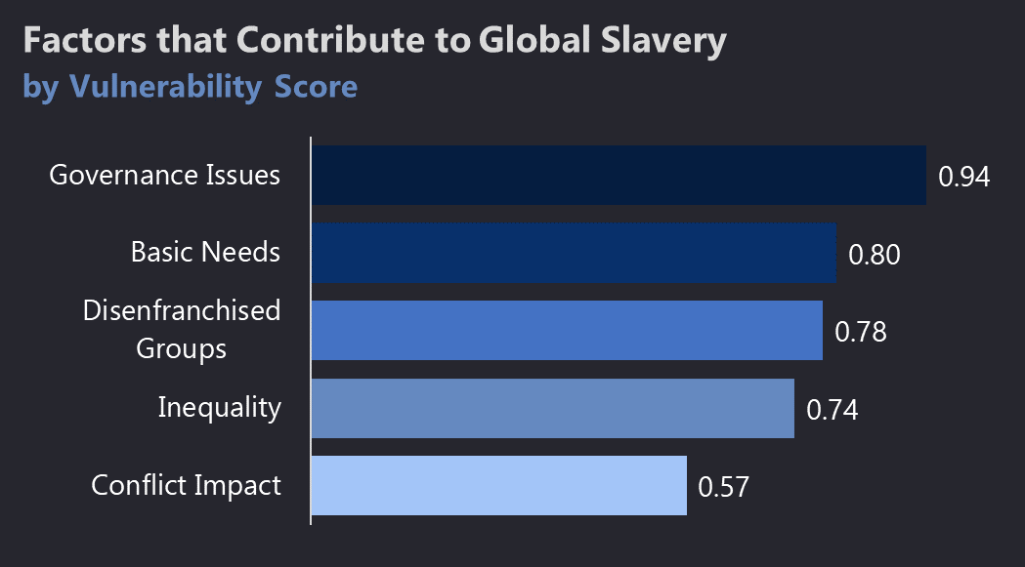
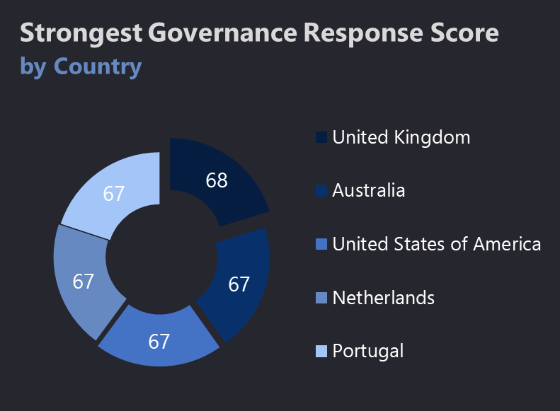
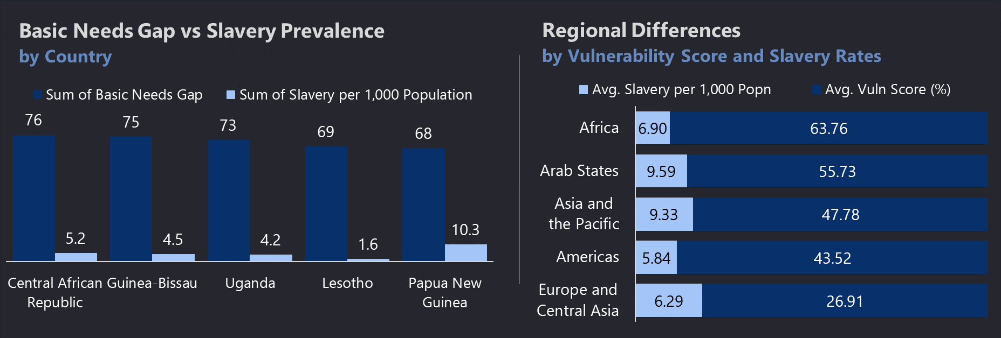
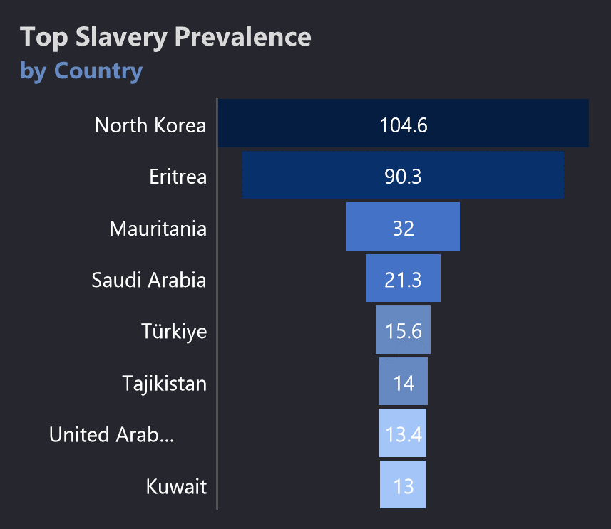
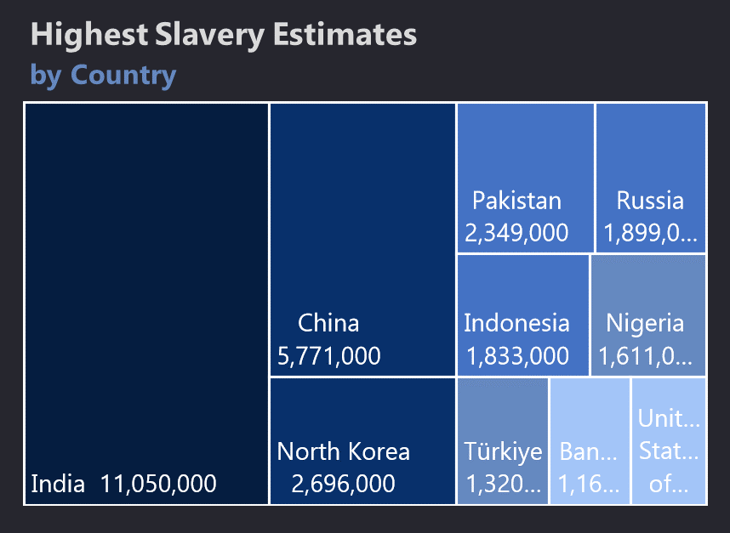

- India has the highest absolute number of people in modern slavery, with over 11 million individuals, which is almost double the number in China (5.77 million), the second on the list.
- Asian countries dominate the chart, with 7 out of the 10 listed countries being from Asia, including India, China, North Korea, Pakistan, Indonesia, Bangladesh, and Türkiye.
- All top-performing countries are within a narrow score range (67–68), showing a high level of uniformity among the top 5 in addressing modern slavery through governance.
- All listed countries are high-income, Western democracies primarily from Europe, North America, and Oceania indicating a trend in stronger anti-slavery governance correlating with economic development.
- Countries with the highest basic needs gap also show notable slavery prevalence. For example, Papua New Guinea has a basic needs gap of 68 and the highest slavery rate per 1,000 population (10.3).
- Despite similar needs gaps, slavery prevalence varies: Lesotho, with a gap of 69, shows a relatively low slavery rate (1.6), while the Central African Republic (gap 76) has a high rate (5.2), and Papua New Guinea even more so.
- Africa has the highest average vulnerability score (63.76%) but only a moderate slavery rate (6.90 per 1,000) compared to the Arab States, which have the highest slavery rate (9.59) but a lower vulnerability score (55.73%).
- Europe and Central Asia show both the lowest vulnerability score (26.91%) and one of the lowest slavery rates (6.29 per 1,000), indicating stronger protections and resilience.
- Governance Issues (0.94) are the strongest contributing factor, scoring significantly higher than any other factor.
- Basic Needs (0.80) and Disenfranchised Groups (0.78) are the second and third highest contributors, suggesting economic and social exclusion as critical drivers.
- North Korea and Eritrea exhibit extreme slavery prevalence, with 104.6 and 90.3 per 1,000 people respectively orders of magnitude higher than other nations.
- Most of the top countries are authoritarian or semi-authoritarian regimes, such as North Korea, Eritrea, Saudi Arabia, and UAE.

In-Analysis Insights
- The extremely high number in India indicates that large population size combined with socio-economic vulnerabilities such as poverty, caste dynamics, and informal labor sectors contribute significantly to modern slavery prevalence.
- The regional concentration in Asia points toward systemic regional issues such as inadequate labor protections, corruption, and ongoing conflicts, making these populations more susceptible to slavery-like conditions.
- The narrow score gap suggests that there’s a global benchmark being approached by top responders, but it may also imply limited room for further measurable improvement using the current governance evaluation methods.
- The Western concentration implies that wealthier nations have more institutional capacity, legal frameworks, and civil society engagement to effectively combat modern slavery, unlike many of the countries with higher slavery estimates.
- There’s a strong association between unmet basic needs and the prevalence of modern slavery, supporting the idea that poverty and lack of access to essential services are direct enablers of exploitation.
- However, the variation in slavery prevalence among countries with similar basic needs gaps implies that other factors such as governance, cultural practices, or geographic isolation also influence slavery outcomes.
- Higher vulnerability does not always directly equate to higher slavery rates, indicating that other enabling or suppressing factors (e.g., law enforcement, cultural norms, migration policies) influence slavery prevalence.
- The strong alignment between low vulnerability and low slavery in Europe suggests that policy infrastructure, socio-economic stability, and governance are effective shields against exploitation.
- The dominant role of governance issues reinforces that weak institutions, poor law enforcement, and corruption create fertile ground for slavery, often more than direct poverty or inequality alone.
- The high scores for basic needs and disenfranchised groups imply that individuals lacking access to essentials or who belong to marginalized identities are structurally vulnerable, making them easy targets for coercion and exploitation.
- The extremely high rates in North Korea and Eritrea suggest state-sponsored or state-tolerated forced labor, where governments may directly exploit or fail to protect citizens from systemic slavery.
- The presence of Gulf countries (e.g., Saudi Arabia, UAE, Kuwait) reinforces the role of migrant labor exploitation, often linked to kafala-style systems, lack of rights, and restricted freedom.

In-Analysis Observations
Chart Gallery 2

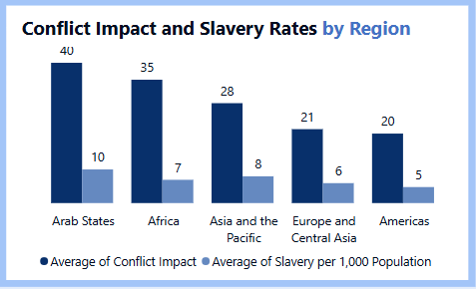
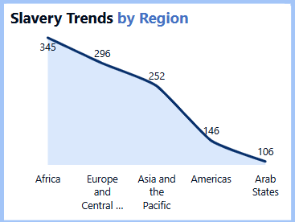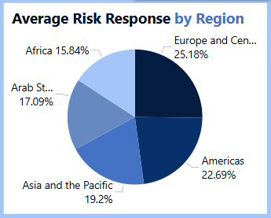
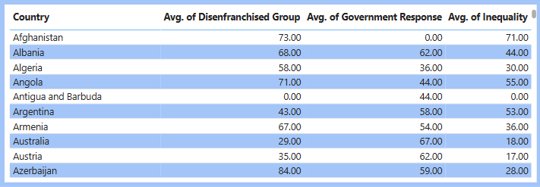
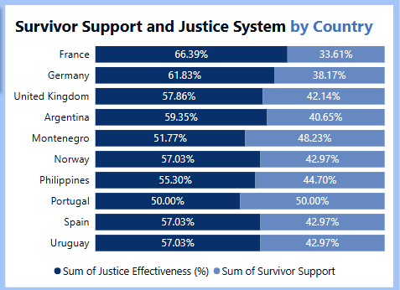

- India leads in absolute slavery numbers with 11.05 million, followed by China (5.77 million) and North Korea (2.7 million).
- North Korea has an alarming slavery prevalence rate of 104.6 per 1,000 population, the highest globally.
- Papua New Guinea has the highest slavery rate among the Basic Needs Gap countries, at 10.3 per 1,000, despite not being in the global top 10 by absolute numbers.
- The Arab States region has the highest average slavery prevalence at 9.59 per 1,000 people, surpassing even Africa and Asia-Pacific.
- Africa records the highest average vulnerability score of 63.76%, correlating with moderate to high slavery prevalence.
- The United Kingdom has the highest government response score (68%), slightly above Australia and the USA (67%).
- Countries with large Basic Needs Gaps like the Central African Republic (76%) and Guinea-Bissau (75%) have moderate slavery prevalence (5.2 and 4.5 respectively).
- Mauritania shows an extreme slavery rate of 32 per 1,000 people, ranking third globally.
- Lesotho, despite having a 69% Basic Needs Gap, shows a relatively low slavery rate (1.6 per 1,000), deviating from the general trend.
- The average global slavery prevalence across all the displayed data is 7.15 per 1,000 population.
- Africa has the highest rate of slavery per 1,000 population (345), closely followed by Asia and the Pacific (251.9). These regions also report the highest conflict impact scores, suggesting a strong link between regional instability and exploitation.
- Countries like the United States and Netherlands exhibit high survivor support (86% and 77% respectively) but significantly lower justice effectiveness (62%). This implies survivors may receive care but not adequate legal redress or prosecution of offenders.
- Ireland and Sweden have similar government response scores (67% and 63%) yet differ in survivor support, pointing to potential inefficiencies in how support is structured and implemented across nations.
- Europe and Central Asia, despite a lower slavery prevalence rate (295.6), report the highest conflict impact (1,096), suggesting that hidden or underreported slavery may be escalating due to geopolitical tension.
- While several countries list forced labor bans, inconsistencies in justice effectiveness and government coordination highlight enforcement gaps.

In-Analysis Insights
- Countries with high basic needs gaps are not always the ones with the highest slavery prevalence, implying that other factors (governance, migration, conflict) significantly influence slavery rates.
- North Korea's high per-capita slavery confirms state-sponsored exploitation rather than poverty-driven slavery alone.
- The Arab region’s high prevalence combined with moderate vulnerability scores suggests that labor migration abuse (especially of foreign workers) is a major contributor.
- Government response does not always correlate with prevalence or severity for example, USA ranks high in response score (67%) but still appears in the top 10 slavery estimates globally.
- Papua New Guinea’s high slavery rate (10.3) despite moderate Basic Needs Gap (68%) indicates potentially overlooked enforcement and systemic issues.
- Lesotho’s low prevalence (1.6) despite a high needs gap highlights that community structure or smaller population size can reduce slavery risk.
- The Europe and Central Asia region’s low vulnerability and prevalence reflects strong legal, economic, and institutional structures.
- Countries like Mauritania and Eritrea, with high per-capita slavery, indicate systemic issues, possibly linked to historical practices and weak legal frameworks.
- Africa’s high vulnerability suggests that anti-slavery interventions in the region must target basic development, healthcare, and education.
- The wide variation in both response scores and prevalence demonstrates the need for tailored, country-specific anti-slavery strategies rather than regional generalizations.
- Focus resources and international pressure on Africa, Asia-Pacific, and parts of Europe with both high slavery and conflict scores. Develop region-specific frameworks that integrate humanitarian aid with anti-trafficking enforcement.
- Countries with strong survivor support must now invest in improving justice systems to ensure that perpetrators are prosecuted and survivors receive long-term legal and social protection.
- Create context-specific policies instead of a one-size-fits-all model. For example, Sweden may benefit from restructuring survivor services, while Ireland could focus on decentralizing aid delivery.
- High conflict impact regions like Central Asia should receive increased surveillance and third-party human rights auditing to detect unreported slavery instances.
- Move beyond legislative enactments and enforce bans through regular audits, penalties, and labor inspections. Governments must publicly disclose enforcement actions to boost transparency and accountability.

Dashboard Visualizations for the Global Slavery Index Performance Analysis for the Year 2023
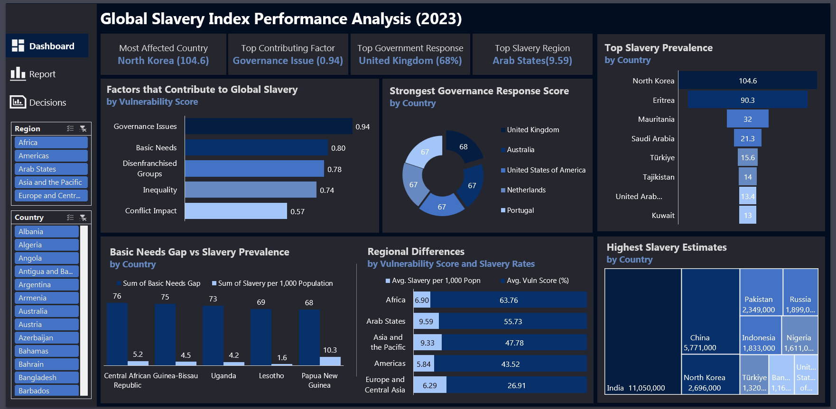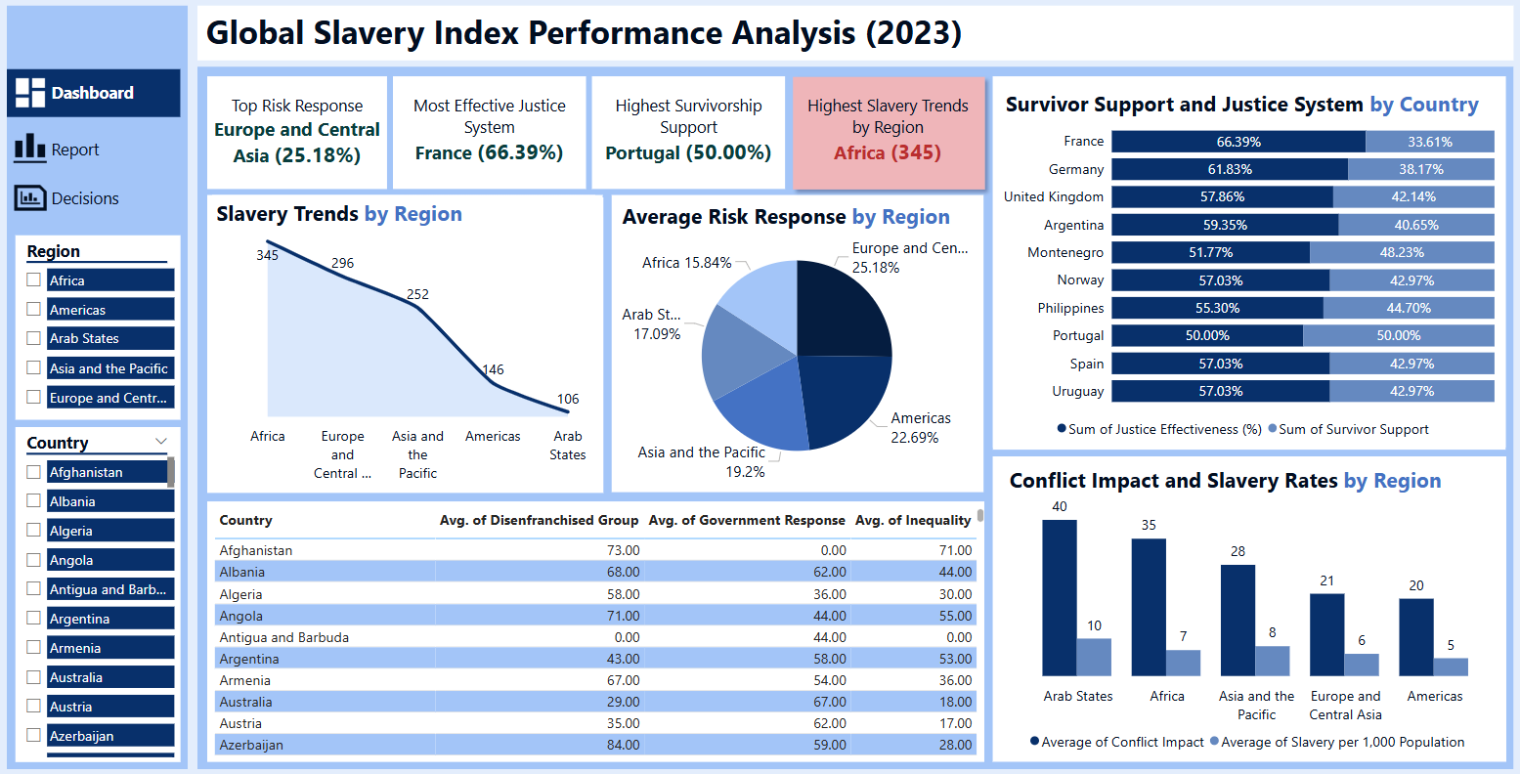

Final Observations from the Dashboards
THE CARDS
The analysis highlights key findings from the Global Slavery Index Performance Analysis Dashboard, emphasizing regions and factors contributing to modern slavery:

- Most Affected Country: North Korea (104.6 average)
- North Korea has governance issues, where citizens face inappropriate governance and control.
- Highest Contributing Factor: Governance Issues (0.94 correlation)
- Weak governance, corruption and lack of enforcement allow modern slavery to persist globally.
- Top Country with Government Response: United Kingdom (68%)
- The UK leads in anti-slavery laws, victim support, and corporate accountability, setting a strong global example.
- Region with Highest Slavery Rate: Arab States (9.59 per 1,000 people)
- Migrant worker exploitation and forced labor are major challenges in the Arab region through conflict issues due to war.

FACTOR THAT CONTRIBUTES TO GLOBAL SLAVERY BY VULNERABILITY SCORE
This observations highlights the key drivers behind global slavery with factors that has the very strong, strong, moderate to strong, moderate and weak correlations with correlations from 0.9-1.0 been the very strong factors, while 0.7-0.9 is the strong factor, 0.5-0.7 is the moderate to strong, 0.3-0.5 moderate and 0.0-0.3 is the weak factor.

The analysis further highlights the key drivers behind global slavery, with governance issues standing out as the most significant factor, showing a very strong correlation (0.94). This suggests that weak institutions, lack of enforcement and systemic corruption contribute heavily to the persistence of forced labor and human trafficking.

Following governance issues, basic needs (0.80), disenfranchised groups (0.78), and inequality (0.74) also play major roles. When populations face economic hardship, lack access to essentials like food and shelter, or are marginalized, they become more vulnerable to exploitation which also shows a very strong correlation as stated above.

Meanwhile, when governance issues, basic needs, disenfranchised groups and inequality are the main factors that contributes to global slavery, conflict impact (0.57) is categorized as moderate, indicating that while war and instability do fuel modern slavery, they are not the strongest underlying factor compared to governance failures and economic deprivation.

STRONGEST GOVERNANCE RESPONSE SCORE BY COUNTRY
This observation underscores the importance of strong governance responses in tackling modern slavery. The United Kingdom leads with the highest governance response score (68), followed closely by Australia (67), the United States (67), the Netherlands (67), and Portugal (67).

BASIC NEEDS GAP AND SLAVERY PREVALENCE BY COUNTRY
This observation highlights the critical relationship between basic needs gaps and slavery prevalence, where deprivation makes populations more vulnerable to exploitation.

Central African Republic has 76 counts for sum of basic needs gap and 5.2 sum of slavery per 1,000 population, Guinea-Bissau is 75 basic needs gap sum and 4.5 slavery per 1,000 population and uganda hs 73 counts for basic needs gaps and 4.2 slavery per 1000 population with Lesotho which has 69 counts on basic needs gap and 1.6 on slavery per 1000 population and papua new guinea has 68 count of basic needs gap and 10.3 slavery per 1,000 population

Countries like Papua New Guinea (10.3 per 1,000 people), Central African Republic (5.2), Guinea-Bissau (4.5), Uganda (4.2), and Lesotho (1.6) show varying degrees of slavery prevalence tied to unmet basic needs.

REGIONAL DIFFERENCES BY VULNERABILITY SCORES AND SLAVERY RATES
This analysis highlights significant regional disparities in slavery prevalence and vulnerability to exploitation. Here are some key observations:
High Slavery Prevalence in Arab States & Asia-Pacific
- Arab States (9.59 per 1,000) and Asia-Pacific (9.33 per 1,000) have the highest rates of slavery per population.
- Vulnerability is driven by migrant labor exploitation, weak worker protections, and forced domestic servitude.
- Governments in these regions must strengthen labor laws and monitoring systems to curb modern slavery.

Africa Faces the Highest Vulnerability (63.76%)
- Africa has the highest vulnerability score, indicating economic instability, weak governance, and conflict-driven exploitation.
- Despite having a slightly lower slavery rate (6.90 per 1,000) compared to Arab States and Asia-Pacific, high vulnerability suggests millions remain at risk.

America & Europe Have Lower Slavery Rates but Systemic Issues Persist
- The Americas (5.84 per 1,000) and Europe/Central Asia (6.29 per 1,000) show lower overall slavery prevalence.
- Despite lower rates, modern slavery still exists in migrant labor abuse, sex trafficking, and supply chain exploitation.
- Stronger corporate accountability and ethical trade policies can help further reduce risks.

TOP SLAVERY PREVALENCE BY COUNTRY
This observation highlights the countries where modern slavery is most prevalent, with North Korea is that citizens are subjected to extreme exploitation under government control.

Following North Korea, Eritrea (90.3) ranks second, where governance issues contribute significantly. Mauritania (32) also remains a critical case, with disenfranchised groups and governance issues.

Other countries, including Saudi Arabia (21.3), Turkiye (15.6), Tajikistan (14), UAE (13.4), and Kuwait (13), show notable slavery prevalence, largely due to migrant labor exploitation and weak worker protections and governance issues.

HIGHEST SLAVERY ESTIMATES
These charts paint a stark picture of modern slavery worldwide, reflecting how millions of people are trapped in various forms of exploitation, including forced labor, debt bondage, and human trafficking.

India has the highest recorded estimate, with over 11 million people affected. This is largely due to factors like economic vulnerability, debt bondage, and weak enforcement of labor protections. Many are exploited in industries such as agriculture, construction, and domestic work, and even in more informal sectors.

Other countries with high numbers such as China 5,771,000, North Korea 2,696,000, Pakistan 2,349,000, Russia 1,899,000 and Indonesia 1,833,000 also face challenges with forced labor it is yet to be eradicated fully, often linked to supply chains, political control or poverty-driven coercion. In North Korea for instance, governance issues and basic needs gap is a concern, while in countries like Pakistan, Indonesia, and Nigeria inequality and basic needs gap is also a concern. The chart's estimate simply shows the rate at which people have been trapped in various forms of forced labor and human trafficking in india.

More Observations from the Dashboards
- Slavery Trends by Region:
- Africa reports the highest slavery trends (345) — significantly higher than any other region. This shows that Africa remains the epicenter of global slavery challenges.
- Arab States have the lowest recorded trends (106) — but this may reflect underreporting rather than true conditions.
- The region’s strict regimes may suppress accurate data collection or transparency.

- Average Risk Response by Region:
- Europe & Central Asia lead in overall response (25.18%), suggesting stronger governance and enforcement. These regions are more proactive in implementing systems to fight slavery.
- Africa lags significantly (15.84%), despite having the highest need.
- The areas most affected by slavery are the least prepared or responsive, indicating an imbalance between burden and capacity.

- Survivor Support and Justice System by Country:
- France excels in legal justice (66.39%), but lags in survivor support (33.61%). Countries are placing more emphasis on punishment over recovery and care.
- Portugal has the most balanced approach (50% justice, 50% support). This rare equilibrium shows it's possible to combine effective law enforcement with humanitarian care.

- Correlation: Survivor Support vs Justice System:
- Most countries focus more on legal systems than on survivor rehabilitation, with few investing equally in both. This creates a justice gap, survivors may get justice but are left unsupported after trauma.

- Conflict Impact and Slavery Rates by Region:
- Arab States and Africa show the highest conflict impact (40 and 35) and also rank high in slavery per 1,000 population. Conflict consistently leads to increased slavery risks due to displacement, poverty, and weakened systems.
- The Americas and Europe have lower conflict scores and lower slavery rates, showing how peace and governance stability protect populations.
- There’s a direct correlation between security and protection from slavery.

- Country-Level Data Table:
- Countries like Afghanistan and Angola have high disenfranchisement (73–71) but low or zero government response. These populations are most exposed, with no state protection or legal recourse.
- Countries like Argentina show moderate inequality (53) and high disenfranchisement (43) but somewhat higher response (58). Some developing countries are making efforts but still need stronger systemic support.

Data-Driven Recommendations for Growth
THE CARDS
The analysis is to recommend various ways to combat slavery globally which include:
- Strengthen Governance & Policy Enforcement
- Enhance legal frameworks, increase penalties for traffickers, and improve institutional transparency.
- Improve International Collaboration & Monitoring
- Strengthen global partnerships, share intelligence, and ensure better tracking of forced labor cases.
- Enhance Corporate Accountability & Ethical Supply Chains
- Mandate corporate audits to prevent exploitative labor practices.
- Increase Public Awareness & Education
- Launch nationwide campaigns to inform vulnerable communities and prevent exploitation.

FACTOR THAT CONTRIBUTES TO GLOBAL SLAVERY BY VULNERABILITY SCORE
This recommendation is valuable in shaping effective anti-slavery strategies. Addressing governance failures, ensuring basic needs, and reducing inequality can significantly lower modern slavery rates. Below are the targeted recommendations.

Strengthen Governance & Enforcement (Correlation: 0.94)
- Implement stricter anti-slavery laws with harsher penalties for traffickers.
- Improve law enforcement training to identify and dismantle trafficking networks.
- Enhance government transparency and accountability to reduce corruption.

Address Basic Needs (Correlation: 0.80)
- Expand social safety nets to protect vulnerable populations.
- Ensure access to education and healthcare, reducing susceptibility to exploitation.
- Promote economic empowerment programs to provide stable employment opportunities.

Protect Disenfranchised Groups (Correlation: 0.78)
- Advocate for equal rights for marginalized communities.
- Strengthen legal protections for migrants, refugees, and displaced persons.
- Support community led initiatives to uplift disenfranchised populations.

Reduce Inequality (Correlation: 0.74)
- Implement policies ensuring fair wages and safe working conditions.
- Bridge gaps in wealth distribution through progressive social policies.
- Encourage corporate accountability in preventing forced labor in supply chains.

Mitigate Conflict Impact (Correlation: 0.57)
- Strengthen humanitarian efforts in conflict zones to prevent exploitation.
- Ensure rapid response and rehabilitation for displaced victims.
- Promote peace-building and stability initiatives to reduce vulnerability.

STRONGEST GOVERNANCE RESPONSE SCORE BY COUNTRY
Here are recommendations to strengthen governance responses to modern slavery, based on the highest-scoring countries (United Kingdom, Australia, United States, Netherlands, and Portugal):

Strengthen Legal Frameworks
- Expand and enforce comprehensive anti-slavery laws to criminalize all forms of exploitation.
- Implement mandatory supply chain transparency requirements for companies.
- Ensure harsh penalties for traffickers and exploitative employers.

Improve Enforcement & Victim Support
- Develop specialized task forces to track and dismantle trafficking networks.
- Establish victim rehabilitation centers, offering legal aid, employment opportunities, and psychological support.
- Provide safe reporting mechanisms to encourage victims and witnesses to come forward and exploitative employers.

BASIC NEEDS GAP AND SLAVERY PREVALENCE BY COUNTRY
Here are targeted recommendations to reduce modern slavery in the countries with high basic needs gaps and significant slavery prevalence:
Strengthen Social Welfare & Economic Support
- Expand food, healthcare, and housing assistance to reduce economic vulnerability.
- Establish job training programs to provide stable employment opportunities.
- Promote microfinance initiatives to help struggling communities achieve financial independence.

Improve Labor Rights & Worker Protections
- Enforce anti-slavery laws to criminalize forced labor.
- Strengthen labor inspections to ensure ethical employment practices.
- Advocate for fair wages and workplace safety to prevent exploitation.

Enhance Education & Awareness Programs
- Integrate anti-trafficking education into school curriculums.
- Launch public awareness campaigns to inform communities about slavery risks.
- Provide legal aid and protection services for at-risk populations.

REGIONAL DIFFERENCES BY VULNERABILITY SCORES AND SLAVERY RATES
Based on the observations of regional differences in slavery prevalence and vulnerability, here are targeted recommendations:
Address Root Causes in High-Vulnerability Regions
- Africa (63.76%):
- Strengthen social welfare programs to reduce poverty-driven vulnerability.
- Improve governance and anti-corruption measures to enhance law enforcement.
- Invest in education and vocational training to prevent exploitation.
- Arab States (9.59 slavery per 1,000 people, 55.73% vulnerability):
- Implement stricter labor protections, particularly for migrant workers.
- Increase corporate accountability to eliminate forced labor in supply chains.
- Enforce anti-trafficking laws with severe penalties for offenders.

Strengthen Labor Laws & Worker Protections
- Asia-Pacific (9.33 slavery per 1,000, 47.78% vulnerability):
- Expand legal frameworks to combat forced labor and domestic servitude.
- Strengthen monitoring systems to ensure compliance with labor rights.
- Promote fair wage policies to reduce exploitation risks.

Americas (5.84 slavery per 1,000, 43.52% vulnerability):
- - Enhance corporate responsibility by mandating ethical sourcing.
- - Strengthen cross-border cooperation to tackle human trafficking.
- - Increase public awareness campaigns to inform people about slavery risks.

Promote Ethical Supply Chains & Corporate Responsibility
- Europe & Central Asia (6.29 slavery per 1,000, 26.91% vulnerability):
- Mandate transparent supply chain audits for businesses.
- Establish stronger laws preventing exploitation in low-wage industries.
- Encourage consumer responsibility initiatives to reduce demand for unethical labor

HIGHEST SLAVERY ESTIMATES
Modern slavery remains a pressing global issue and stronger measures are needed to combat it effectively by employing policy recommendations and financial inclusion for vulnerable populations.
- Provide better data sharing strategies and technology driven solutions to detect trafficking patterns.
- Countries with high slavery estimates including India, China, North Korea, Pakistan, Russia, Indonesia, Nigeria, Turkey, Bangladesh and the U.S. must strengthen legal frameworks, enforcement mechanisms, and victim support systems.
- Government should address poverty rate, inequality and labor exploitation as it is crucial in reducing vulnerability to modern slavery.

More Recommendations
- Slavery Trends by Region:
- Scale up anti-slavery interventions in Africa, including community-based programs and institutional support. Africa must be the priority zone for donor support, NGO presence, and UN-backed programs.
- Improve data collection and transparency in the Arab States, possibly through third-party international observers. Real visibility will only come when the data reflects ground realities, not political filters.

- Average Risk Response by Region:
- Deploy governance-strengthening programs in low-response regions like Africa and the Arab States. This includes training law enforcement, funding legal reform, and supporting civil society.
- Share policy frameworks from high-performing regions like Europe with lower-performing regions. Replicating success stories can shorten the learning curve for emerging regions.

- Survivor Support and Justice System by Country:
- Encourage countries to adopt integrated survivor-centered justice systems. Legal victories mean little if survivors are not healed, supported, and reintegrated.
- Create global minimum standards for survivor support that countries must report on annually. This keeps countries accountable for the human side of anti-slavery efforts, not just legal stats.

- Correlation: Survivor Support vs Justice System:
- Bridge the justice-support divide by making funding for legal systems conditional on survivor services. Tie performance funding and support to balanced outcomes not just arrest numbers but survivor wellbeing.

- Conflict Impact and Slavery Rates by Region:
- Integrate slavery prevention into humanitarian responses during conflicts. Refugee camps and conflict zones need embedded anti-slavery protection units or NGO partners.
- Strengthen early warning systems where conflict risk is rising. Use data to anticipate slavery surges in fragile states and intervene early.

- Country-Level Table:
- Target highly disenfranchised countries like Afghanistan and Angola with focused global aid and protection programs. These places need rapid government reform and international watchdog oversight.
- Support mid-tier countries (e.g., Argentina) with infrastructure for monitoring and scaling successful efforts. They're on the right path and can become regional leaders with proper investment.

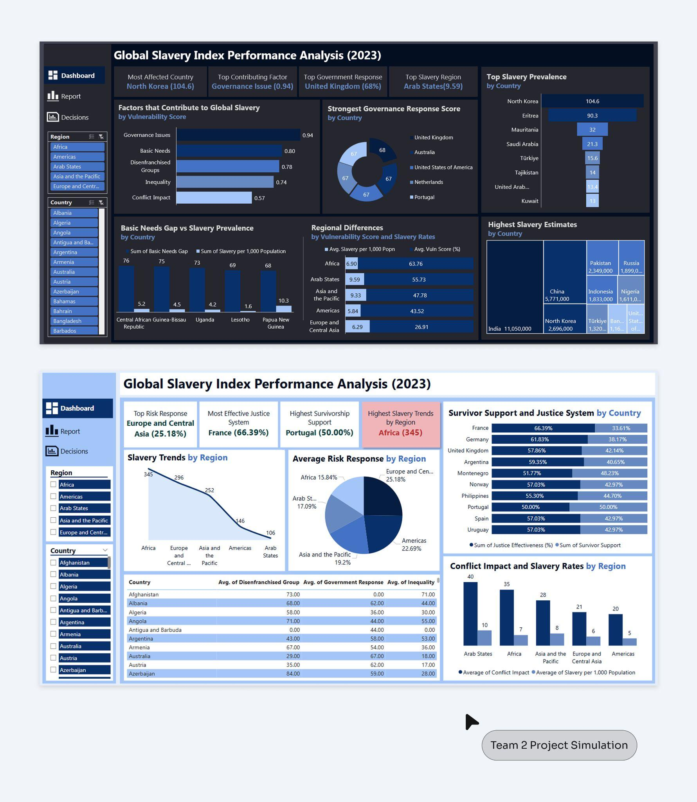

Thank You!

Reference: Global Slavery Index | Walk free. (n.d.). Walk Free. https://www.walkfree.org/global-slavery-index/

